Name

Address

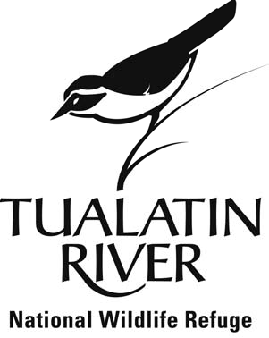
Environmental Education
Volunteer Naturalist Application Form
Thank you for your interest in the Volunteer Naturalist Position at the Tualatin River National Wildlife Refuge. Please fill out the following application to the best of your ability and we will be in contact with you shortly.
During training, volunteers will be provided with a solid foundation for assisting with the Refuge’s education programs. During four training sessions, volunteers will learn about natural history, wildlife observation skills, and practice techniques to successfully work with youth and the public. Both experienced volunteers and enthusiastic novices are encouraged to apply.
We are looking forward to hearing from you!

City State Zip

Email Phone

Please answer the following questions. Attach additional pages if necessary.

1) Briefly, tell us about yourself as it pertains to the volunteer position. Why are you interested in becoming a volunteer naturalist? What experience do you have experience working with youth and the public?

2.) Volunteer duty times will be scheduled in advance and selected by the volunteer themselves. They occasionally will require that volunteers are able to donate their time during school hours as well as weekend days. Generally, will you be available at these times? Note: Volunteers will be primarily working outdoors, sometimes in inclement weather.

3.) In exchange for 26 hours of naturalist training provided by the Refuge, volunteers will be required to donate 35 hours of service towards the Refuge’s education programs within the year following the training. Are you able to make this commitment of training and service? ________
If not, are you interested in other education and recreation program volunteer opportunities at the
4.) Please provide up to three personal or professional references who can speak to your qualifications to serve as a volunteer. Include names and contact information.

Name Phone

1. ________________________________________ __

2. __________________________________________ _

3. __________________________________________ _______

Applications are due by Thursday March 11th, 2019 and final 25 participants will be notified of acceptance throughout the recruiting process. Further details will be made available upon confirmation of registration. Please return this application electronically or by mail to:

Tiffany Mancillas
Friends Environmental Education Specialist
Tualatin River NWR
19255 SW Pacific Hwy.
Sherwood, OR 97140
Tiffany_Mancillas@friendsoftualatinrefuge.org
Phone: 503-625-5945
Fax: 503-625-5947

